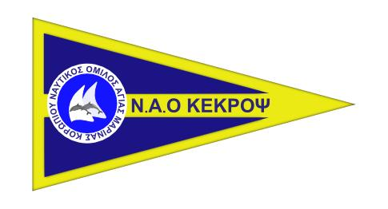
NAO KEKROPS

Registration Form
GREEK OPEN NATIONAL CHAMPIONSHIPS

WINDSURFING CLASSES: TECHNO U15, TECHNO U17, TECHNO PLUS 293
April 29th – May 2nd 2019

CLUB/COYNTRY

 | Name &Surname | Passport No | Sail No. | Registration |  | Date of Birth
 |  |  |  | Class | Sail Size
1
2
3
4
5
6
7
8
9
10
Please, use CAPITAL letters

Team Leader / Coach

Mobile Phone

Email
Declaration I agree to be governed by the racing rules of sailing and by all other rules that govern this event, and I accept the penalties assessed to me under these rules and such other action as may be taken, subject to review procedures as are provided herein, as the final determination of any matter arising under these rules, and I agree not to report to any court or tribunal not provided herein with respect to such determination.
I accept that I participate with my own risk under fundamental rule 4 of the racing rules of sailing it is my solely responsibility to decide whether or not to start or to continue to race and I agree not to report to any court or tribunal with respect to such decision and its consequences.
Date. Signature

Racing License Insurance Advertising
Measurement Certificate Entry Fee

